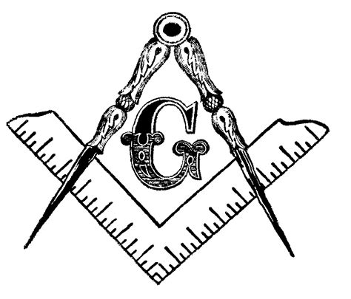
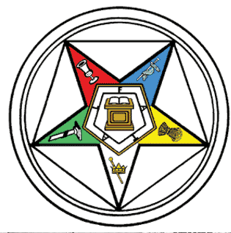
Most Worshipful Prince Hall Grand Lodge
OF WEST VIRGINIA, F. & A. M., INCORPORATED
Organized 1877 A.L. 5877
And
ELECTA PRINCE HALL GRAND CHAPTER OF WEST VIRGINIA
ORDER OF THE EASTERN STAR
PRINCE HALL AFFILIATION
ORGANIZED JANUARY 16, 1914

Re: 2020 Mid-Atlantic Region Conference of Grand Masters, Grand Matrons and Grand Patrons
Dear Most Worshipful Grand Masters, Grand Worthy Matrons and Grand Worthy Patrons;
This letter is to announce the plans for the 2020 Mid-Atlantic Region Conference of Grand
Masters, Grand Worthy Matrons and Grand Worthy Patrons. The Most Worshipful Prince Hall Grand Lodge (MWPHGL of WV) and Electa Prince Hall Grand Chapter, Order of the Eastern Star of West Virginia is honored to host the Conference, which will be held Friday and Saturday, March 20-21, at the Holiday Inn, 301 Foxcroft av, Martinsburg WV.
Conference Registration: The Conference registration fee is $150.00 for foreign jurisdictions, $75.00 for WV Masons and Eastern Stars. Included in this fee is one breakfast ticket, one lunch ticket and one banquet ticket. Please complete and return the enclosed registration form for each registrant along with the appropriate fee in the form of a cashier's check, money order, Grand Lodge or Grand Chapter check made payable to the "MWPHGL of WV" (Mid-Atlantic Conference on the memo line) no later than Monday, March 4, 2020. After March 4, 2020, a late fee of $20 will be charged. Please feel free to make as many copies of the registration form as necessary for your jurisdiction.
Hotel Accommodations: Room rates at the hotel are $119.00 for a single or double per night, plus applicable sales tax of 13.25%. Reservations must be made by February 21, 2020 for this rate. After this date you will be charged the prevailing rate of Holiday Inn Martinsburg, 301 Foxcroft Avenue, Martinsburg WV 304-267-5500. Check-in is at 3:00 pm and check-out is 12:00 noon. Early arrivals will be accepted on a space available basis.

Conference Agenda: We will be having a community service event to have the Grand Masters, Grand Worthy Matrons, and Grand Worthy Patrons visit the local Veterans Administration hospital. We will also have an event Saturday night which will culminate the conferences' activities as well as recap the community service event for the day. So, we ask that you please stay through the weekend and not leave after the joint meeting Saturday.
The Grand Masters, the Grand Matrons and Grand Patrons will have their individual sessions and we will wrap up with a Joint Meeting. This is an opportunity to share ideas and make plans to carry to the Conference of Grand Masters, and the Conference of Grand Matrons and Grand Patrons in May 2020. Grand Masters, please submit your agenda items to:
MWGM Jeffrey M Calcote, 2 Locust av, Wheeling, WV, 26003. jcalcote@comcast.net
Grand Matrons send yours to: GWM Angelia Russell, P.O. Box 207, East Bank, WV 25067. angelia.russell@gmail.com.
Conference Schedule of Activities: This year's Conference activities will be :

- Friday:
12:00pm – 5:00pm Registration
5:00 - 7:00pm Planning Meetings
9:00pm – 12:00am Mardi Gras theme Reception

- Saturday:
7:00am -8:30am Opening with Breakfast
9:00 – 10:00am Memorial Service
10:00am – 1:00pm community Service
10:00am – 1:00pm workshops
1:30pm – 3:00pm Lunch
3:30pm – 5:00pm Breakout meetings
5:15pm – 6:30pm Joint Meetings
8:00pm – 11:00pm Dinner and Program
Fraternally
Honorable Jeffrey M. Calcote Sr. Angelia Russell
Most Worshipful Grand Master Grand Worthy Matron

